**General Application Features**

These features are common to NetView applications which are browser independent, i.e. accessible through all Internet browsers.



**Header Bar:** These features can appear in the upper-left-hand corner of an application window, located on the grey Header bar that displays the location and application names.

Shortcut Bar: Use the Shortcuts Bar here to open other applications via shortcuts from inside the active application.  For more information on shortcuts and the Shortcuts Bar, see **"Using Shortcuts."**

Display Calculator: Click this icon to display a calculator.

Print Screen: Click this icon to print the screen currently displayed on your monitor.

Display Calendar: Click this icon to display a calendar.

eDocs: If an application can have documents electronically added to its files (eDocs), this cloud icon will appear.  The icon will **only activate** when there is a file pulled up in the program that can have eDocs attached to it.  If a file already has any eDocs attached, the cloud icon will be **blue** and show a number indicating how many documents are attached:



Clicking on the cloud will let you view and edit the eDocs attached to that file, as well as add new files (the image below is for a file that does not have any eDocs added yet):

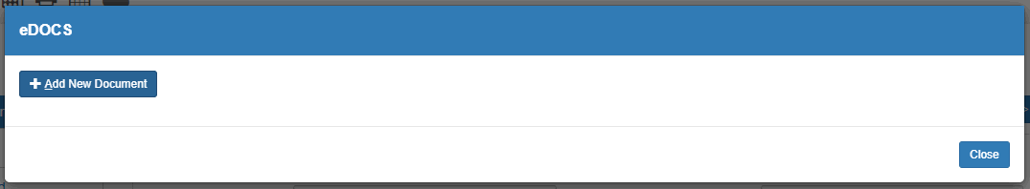

For more information on adding and editing eDocs, see **Document Management (DM)**, which allows you to view and manage eDocs system-wide.



**About Application:**This application (pictured above) is located on the far right of the Header Bar, next to the application's name. Click this icon to see the application's version and copyright information, as well as the phone numbers and email address for HBS Support in both the U.S.A. and Canada.



**Menu:**You can also access the Desktop Menu from a Menu tab on the side of the screen (pictured above).  The **Help** tab in the menu will also automatically open to the Help page for that particular application when opened.  For more information on using the menu, see **"Menu."**